THE FIRST BAPTIST CHURCH, PAINTED POST, NY
We are a welcoming and affirming fellowship of loving & caring families
(607) 962-1736 www.fbcpaintedpostny.org
Join us on our Website or Facebook for a virtual service on Sunday, March 22
Rev. Rose will be delivering the message entitled: “The Lord Looks On The Heart” (1 Samuel 16:7)
The scriptures are Ephesians 5: 8-14 & 1 Samuel 16: 1-13
Rev. Rose’s & the church’s message of Hope, Peace, Joy & Love will be online by 12 noon

Pianist/Organist, Cathy Weil Rev. Richard Rose Choir Director, Wendy Griffin

March 21 – Virtual Baby Shower for Chelsey Cooper
March 29 – Online Morning Service with Rev Rose
Please remember to keep up with your pledges
by mailing them in or dropping them off at the Office
Our Mission for March: ABC – USA World Mission Offering (Goal; $250)

Kindly keep the following in your thoughts and prayers:
Helen Conklin ~ Gordie & Alyce Loomis ~ Mary Johnson ~ Dick Naylor ~ Ken Naylor ~ Clara English
Alan (Be Crans’ grandson) ~ Catherine Fish ~ Becca Lowe ~ Judy Everitt ~ Ruth & Vic Campbell
Eveline Shauger ~ Virginia Harper (Cindy Hale’s mom) ~ Amy Grant’s parents ~ David (Cindy’s brother-in-law)
Patty & Bill (friends of Deb Kulkowski)~ Loren Vinal (Sandra Olsen’s friend) ~ Heather (Daryl’s cousin)
Kelly Gee & Greta Meyers (Dan Borden’s cousin & her daughter) ~ Tyler Claussen (Jill’s nephew)
Mark & Eli (Mary’s brother & nephew) ~ Anna (Jen Kostera’s sister) ~ Jessie’s family (friend of Kiersten) Lance (Cathy’s friend) ~ Doug & Lori Wilcox (Margie’s friends) ~ Elmer Borden ~ Allison Grant ~ Wendy’s Dad
Marge Miraglia ~ Mike & Gerry (Friends of Sheri Morse) ~ Flora (Daisy’s friend) ~ Else Høydal (Sandy’s sister)
Richard Jelison (Cindy Bradshaw’s brother) ~ Roy Brown & Katie Tuttle (Sue McInroy’s friends)
Refugees ~ People of Italy & Wuhan, China & all those affected by the Coronavirus ~ Peace
Please contact Lori at the church office with updates & names to be added to (or removed from) this list

Attendance on March 15: 38

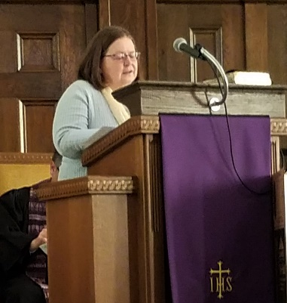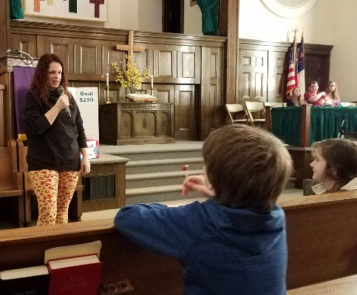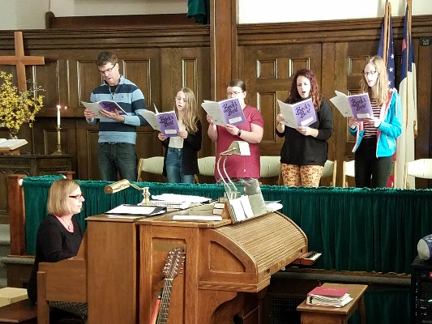
Liturgist, Sue McInroy Children’s Story, Mar 15 Choir, Mar 15

We are looking for a person to become our new Office Manager.
For information contact the church office
March 28 @ 5.00 pm – Chicken & Biscuit Dinner - POSTPONED

